Year: 2025 Semester: Spring Project Name: Electronic Skee Ball

Date of First Submission: October 18, 2024 Last Modified: October 12, 2024

Team Members (#1 is Team Leader):

Member 1: David Fall Email: dfall@purdue.edu

Member 2: Andrew Cali Email: acali@purdue.edu

Member 3: Jennifer Ferguson Email: fergu157@purdue.edu

Member 4: Madeline Flanagan Email: flanag24@purdue.edu

Project Abstract:

The student project consists of a more user-friendly adaptation of a traditional skee-ball machine in which many of the mechanical components are replaced with electronic counterparts, such as a joystick and button mechanism for aiming and firing the ball.

1.0 Description of Problem:

Recreational activities like arcade games are an important part of entertainment and social interaction for people around the world. However, individuals with disabilities often face barriers to participating in these experiences, especially in games that require physical activity, such as skee ball. According to the World Health Organization, an estimated 1.3 billion people experience significant disabilities, resulting in a large portion of the population being unable to engage in activities that require physical mobility [1]. Arcade games that involve traditional throwing motions, like skee ball, exclude those who cannot perform these actions, thereby limiting access to recreational opportunities. Inaccessible recreational spaces hinder efforts to promote inclusivity, which is essential for improving the quality of life for people with disabilities [2]. As the demand for accessible entertainment continues to grow, many existing designs still fail to accommodate all users. Addressing these accessibility gaps is critical for fostering a more inclusive society that values equal participation in recreational activities.

2.0 Proposed Solution:

Our project aims to redesign the traditional skee ball arcade game to make it more accessible for people with disabilities, particularly those unable to perform the standard throwing motion. Instead of throwing the ball, the user will control a spring-loaded mechanism using a joystick and button system. One of the features of this design is the joystick, which allows the user to precisely adjust the direction of the ball by moving it left or right, while the button controls the launch strength based on how long it is pressed—shorter presses result in softer throws, and longer presses create more powerful launches. An LCD display will provide real-time feedback on the chosen direction and the power of the throw, allowing users to visually confirm their settings before launching the ball. Additionally, a sound system will offer audio cues to guide the user through gameplay, signaling when the ball is ready to launch or when it reaches a scoring target. These features work together to ensure an intuitive and accessible experience for all users. Please see Appendix 1 for our initial proposal sketches.

3.0 ECE 47700 Course Requirements Satisfaction

ECE 47700 is an embedded systems course which requires many design constraints for the student project, including both hardware and software constraints. To satisfy this, the student group will incorporate a variety of hardware systems and interfaces, along with the software to drive the hardware, in order to achieve the functionality outlined in Section 2.0 above. These systems and interfaces include an LCD display, one motor and a controlling analog joystick, one motor and a controlling external push button, several ultrasonic sensors, and a speaker system. The main computer of the project will be provided by STM32f091 development board, which will provide the software implementation necessary to configure these hardware systems to accomplish the desired functionality of the project.

3.1 Expected Microcontroller Responsibilities

Much of the functionality described in Sections 2.0 and 3.0 above must be implemented via a microcontroller. The responsibilities of the microcontroller in each of these facets is outlined as follows:

Ultrasonic sensors: in order to interface with the ultrasonic sensors, the microcontroller will utilize general purpose input output to send a triggering signal to each sensor in order to send an initial output signal from the sensor. Then, the sensors will receive a responding signal, which will be returned to the microcontroller. The microcontroller will utilize these signals and its onboard digital clock to determine the distance being recorded by the ultrasonic sensors.

Speakers: the microcontroller will generate PWM signals to output to an amplification circuit, which will drive the audio on the speakers.

Joystick input: The microcontroller will read the analog positional input from the joystick via ADC and use this signal to position the corresponding motor (the motor controlling the angular position of the spring).

Button input: The microcontroller will read the input from the external push button, implement software to debounce it, and use the input to drive the corresponding motor (the motor loading the spring).

Score recording: the microcontroller will read and write high score data to non-volatile memory to preserve game statistics between settings.

Score display: The microcontroller will generate score data and drive it to the external LCD displays via a peripheral communication interface.

3.2 Expected Printed Circuit Responsibilities

Another key component of the proposed solution is the printed circuit board in the final model. The board must offer an efficient and reliable integration of the various components necessary for achieving the desired features and functionality of the project. Thus, our printed circuit board will contain the following:

Power supply and regulator: The board will feature an interface for accepting an external power supply and regulating this supply to the correct format and intensity necessary for each component in the design (controllers, sensors, other peripherals, etc.).

External push button: The board will host an external push button and the circuitry required to map its state to the main computer.

External joystick: The board will host an external analog joystick and the circuitry required to map its state to the main computer.

Audio amplification: The board will host an audio amplification circuit and the circuitry required to translate the original audio signals from the main computer, through the amplification circuit, and finally to the external port where the speaker can connect and receive the amplified signal.

Connectors: The board will host a variety of electrical connector ports to efficiently and safely connect remote devices (such as the LCD displays, speaker, and ultrasonic sensors) to the circuitry on the board so that the main computer and other onboard components can interface with the remote components.

Main computer: The board will host an STM32 controller and its functional pins to serve as the main computer driving the remaining components.

4.0 Market Analysis:

The market for accessible recreational devices is substantial, driven by the increasing focus on inclusivity. In the U.S., 26% of adults live with disabilities, highlighting the demand for products that accommodate physical limitations [3]. Globally, the arcade gaming market is projected to grow by $1.66 billion between 2021 and 2025, fueled by rising demand in recreational centers, amusement parks, and arcades [4]. Making popular games accessible could help these venues attract a broader audience and enhance user engagement. Beyond individual users, organizations that prioritize inclusivity—such as rehabilitation centers, community centers, and schools—would benefit from accessible gaming equipment. Corporate social responsibility and diversity, equity, and inclusion (DEI) initiatives are further driving interest in accessible entertainment, as businesses increasingly aim to promote equal participation for all. The U.S. Department of Education has emphasized the importance of creating inclusive recreational spaces, adding institutional backing for such innovations [5]. By addressing this market, our redesigned skee ball game fosters inclusivity while tapping into a growing financial opportunity within the arcade gaming sector.

5.0 Competitive Analysis:

Skee-Ball is not a new concept; this nostalgic arcade game has been entertaining players for over a century, However, our enhanced version of the game incorporates modern features, making it more accessible and user-friendly. Notably, we’ve integrated an LED scoring system, user-friendly joystick controls, and an efficient ball return mechanism. Many current Skee-Ball models lack those options, making them less accessible to some users. Historically, Skee-Ball machines relied on mechanical mechanisms to track scores and return balls, but advancements in technology lead to game improvement. It is crucial to analyze similar patents, products, or projects that already exist when making your own project. By examining alternatives, we can identify features that we want to incorporate into our own project.

5.1 Preliminary Patent Analysis:

Ever since the arcade game Skee-Ball was founded by Joseph Forestier Simpson in 1907, there have been numerous different variations of the game patented, each introducing new technological advancements while maintaining the core mechanics. As technology evolved, so did the game’s design and functionality.For example, in 1942 with Harver S. Hoover patented an “indoor game”, a more compact version of Skee-Ball that incorporated an audible aspect and a ball return. Then, in 1953, Leslie B. Anderson’s “Skee ball game apparatus” introduced a trigger system that sent a signal to the scoreboard directly, replacing the original mechanical lever system. These innovations demonstrate how the game has adapted over a century while still preserving its nostalgic appeal.

5.1.1 US905941A:

Patent Title: Game apparatus

Patent Holder: Joseph Fourestier Simpson

Patent Filing Date: 11/12/1907

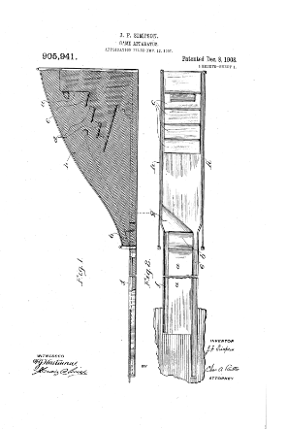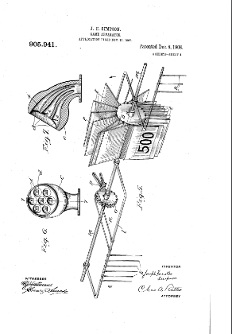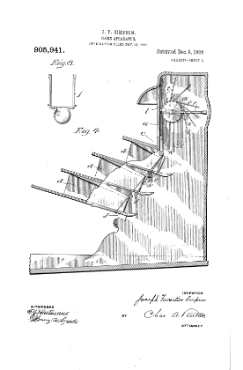

This is the original patent [6] for the Skee-Ball game, alongside the original design for the game. Players roll a ball up an inclined slope, causing it to “jump” off a ram and into a scoring hole to earn points. Notably, the design includes an automatic scoring system. As the ball passes through one of the scoring holes, there is a lever which will activate a system of rods and levers that will count and change the score. Each respective hole will have its own respective lever. There is a secondary lever inside the mechanism to ensure there is reverse movement and ensuring accurate score keeping. The playing surface is constructed with a sloped triangular design, directing balls that may fall between the end of the board and the target into a collection area under the board. There is a clear path to the collection area always to prevent a blockage.

5.1.2 US2724594A:

Patent Title : Skee ball game apparatus

Patent Holder: Leslie B Anderson

Patent Filing Date: 07/24/1953

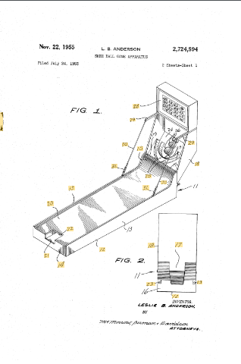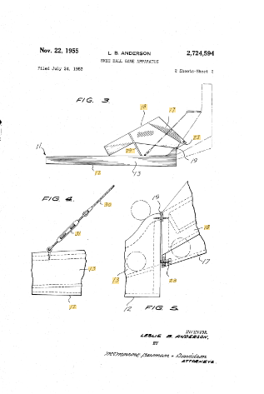

The invention [7] is an enhanced game apparatus designed for a ball-rolling game, where the player rolls a ball along an alley, and the ball is propelled by a ramp at the alley’s rear into a scoring pocket. As the player rolls the ball, it moves along the playing surface toward the ramp, which launches the ball upwards, typically hitting the scoring panel. If aimed correctly, the ball will pass through one of the scoring openings, registering a score on the display board. Once the score is recorded, the ball drops down a chute at the lower end, then rolls back toward the alley’s front so that the player can retrieve the ball. Also this design is a foldable design to reduce volume for easy storage and transportation. Also the ball return mechanism is different with a chute that allows balls to be returned to the front of the alley after scoring, enhancing gameplay overall. Additionally, the scoring system is unique compared to traditional designs. Beneath each scoring hole, a series of trigger elements are strategically placed and connected to a register mechanism, ensuring accurate and immediate score tracking as each ball passes through the designated hole. .

5.1.3 US2326859A:

Patent Title : Indoor game

Patent Holder: Harter S Hoover

Patent Filing Date: 05/21/1942

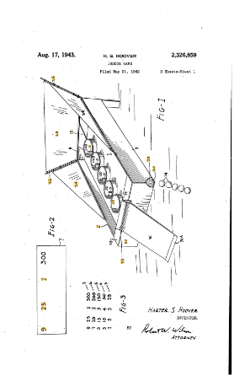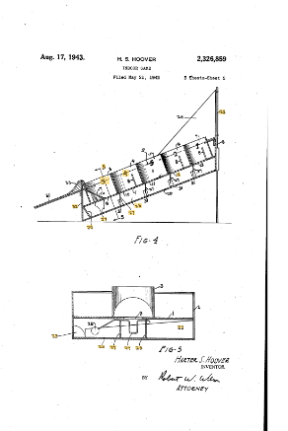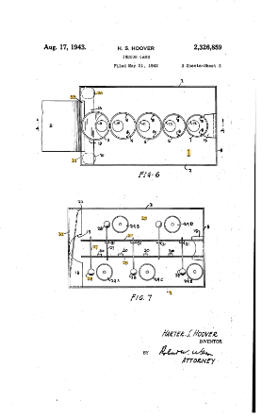

This game design [8] is quite similar to Skee-Ball, yet it varies in several ways. While it maintains the concept of rings and propelling balls to “jump” into a hole, this design is more compact and easier to store. In addition, the scoring mechanism is different, featuring a bell system where each hole triggers a bell with a distinct pitch, indicating the score based on the sound. The mechanism for adding points is also unique, since it turns each ring 90 degrees, a new series of scoring numerals appear, allowing for variation in scoring. Finally, the ball return system is different as well. After a ball is propelled into one of the rings or it misses one of them, the ball rolls beneath the playing surface in a guided path. It falls into a chute that leads the ball to the player at the front of the game. This eliminates the need for manual ball collection.

5.2 Commercial Product Analysis:

Since the release of the arcade game Skee-Ball in the early 20th century, the game has undergone significant evolution while maintaining its nostalgic atmosphere. Various iterations, including video game adaptations, portable household versions, and virtual games, have emerged alongside the original arcade game. Despite these diverse applications, all versions relate to the original concept described in the original patent by Joseph Foirestier Simpson, who invented and patented Skee-Ball in December 1908. In this classic design, the ball “jumps” into a scoring hole, which then outputs a score. However, there are some similarities, but these commercial products differ from our concept of a more accessible Skee-Ball game. The most affordable option available is the portable Skee-Ball game by Buffalo Games, priced at $35.00, while the most expensive game includes the commercial Skee-Ball machines by Skee-Ball Inc found in arcades.

5.2.1 Classic Skee-Ball Home Arcade:

Price: $8,995.00

Company: Skee-Ball Inc

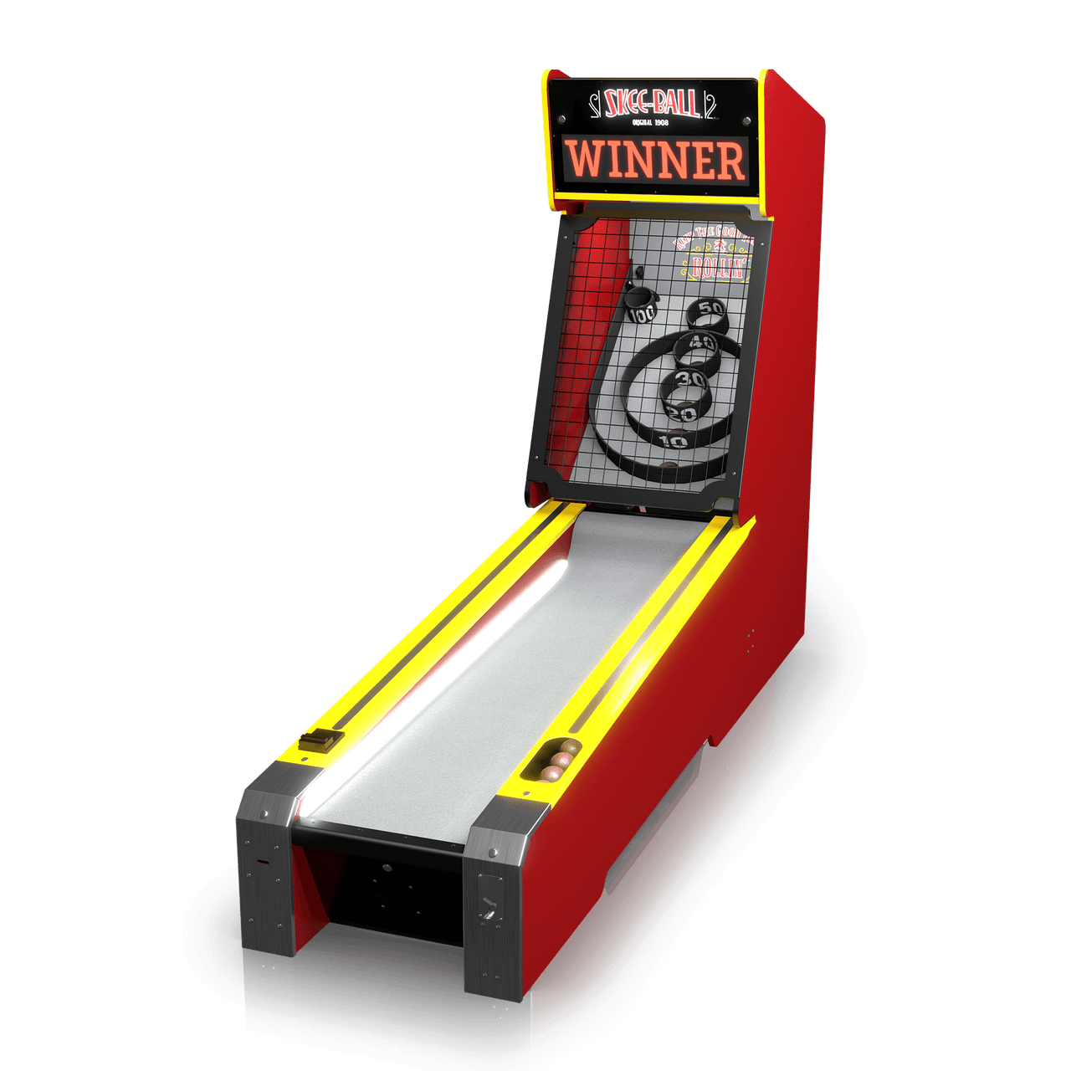

The Classic Skee-Ball Home Arcade game [9] is made by Skee-Ball Inc. This company makes all different versions of the iconic game, Skee-Ball, like the Deluxe, Premium, Classic, etc. This company is the company that franchised and popularized the game, they maintain the nostalgic feel of the game while offering modern features. While the 10-foot ramp adds to its authenticity, it makes the machine less practical for smaller spaces and more suitable for arcades or larger game rooms. Key features of this model include a lit playfield with classic targets, authentic carnival arcade sounds, and an automatic ball collection and return system on the right side. Additionally, the game offers various modes, such as Hundo Rally, No Look-Skee, Around the World, and Black Out, providing players with different gameplay options.

.

5.2.2 Skee-Ball:

Price: $4.99

Company: Nintendo

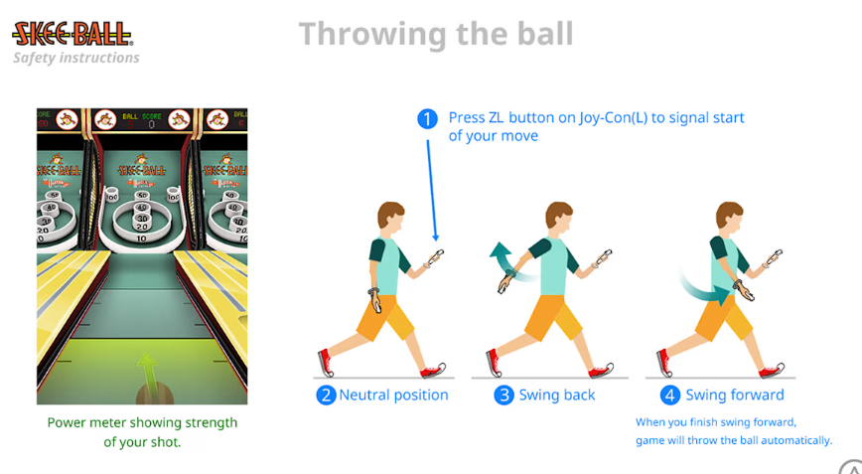

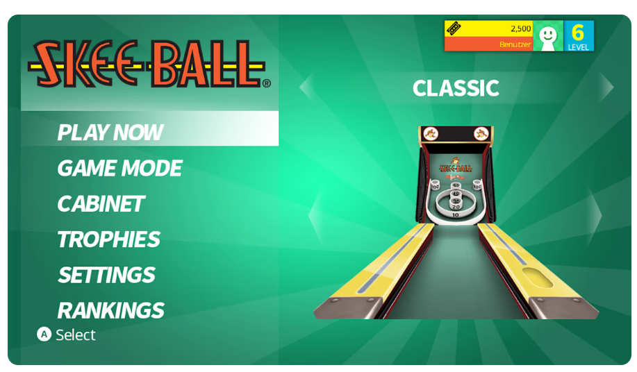

Skee-Ball [10] is a bowling-inspired game developed by Nintendo for the Nintendo Switch, offering a virtual experience that deviates from the traditional arcade game. Unlike the physical Skee-Ball game board, the digital adaptation allows players to enjoy the game anywhere using motion controls in TV mode to simulate throwing the ball. There are also multiple different types of game features like Call your Shot, Speedball, Horse, Hangman, and Countdown. Additionally, there is also a point system with features that enable ticket redemption for power-ups, score multipliers, magic balls, new game boards, etc. making a versatile game.

5.2.3 SkeeBall The Classic Arcade Game :

Price: $35.00

Company: Buffalo Games

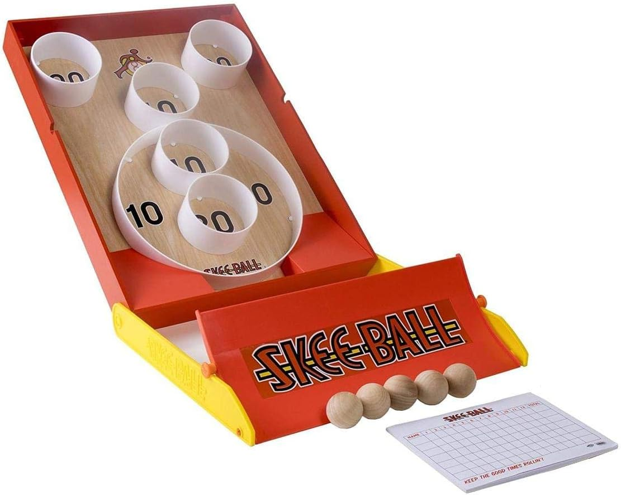

This version of Skee-Ball made by Buffalo Games is quite similar to the original arcade game, yet it differs in several significant ways. This is a more compact game system that is portable and can be taken on-the-go. However, due to its smaller size, it lacks the traditional ramp found in the original game, requiring a flat surface for rolling the ball towards the jump that leads to the scoring holes. In addition, there is not an automatic score system, instead players have to keep track of their own personal scores. This is a good replacement for playing Skee-Ball at home, however some of the arcade specific features – automatic arcade music, score system, ball return mechanism – are not included in this compact version.

5.3 Open Source Project Analysis:

Even though the classic Skee-Ball game has been around for over a century, there are not that many open-source projects dedicated to recreating a Skee-Ball game. The limited open-source projects may be due to the fact of the traditional design and mechanical operations that define Skee-Ball, making it less appealing for modification. However, I managed to find one notable open-source project that stood out.

5.3.1 Automatic Scoring for a Small Skee-Ball Game:

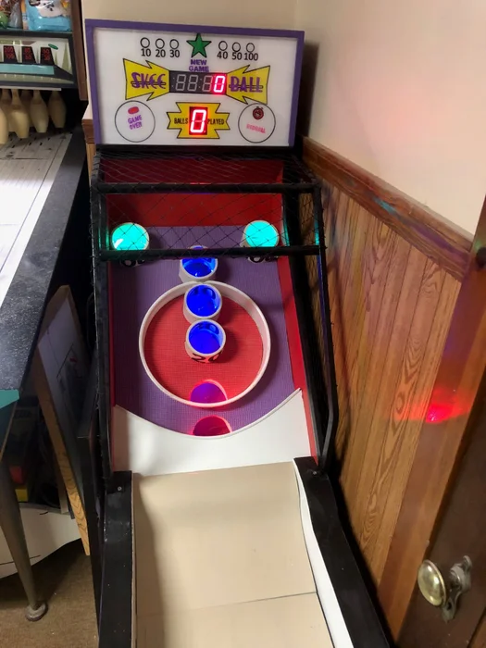

This open-source project [12] uses an Arduino board to manage the game’s flow and scoreboard functionality. This allows the integration of communication between the components including arcade micro-switches, LED displays, and the scoring system. This project used an Arduino board, which is a widely recognized open-source hardware platform, since you can replicate the hardware with similar components and with the provided source code linked in the website. Using the Arduino board and provided code, one can create their own Skee-Ball game at home, and an automatic scoring system. However, from personal experience, the author claims that sometimes the Skee-Ball fails to activate the micro-switch arm when it falls through a scoring ring, so the author wished he used and IR break-beam sensor for this implementation.

6.0 Sources Cited:

[1] World Health Organization, “Disability and health,” World Health Organization, Nov. 24, 2021. [Online]. Available: <https://www.who.int/news-room/fact-sheets/detail/disability-and-health>

[2] Centers for Disease Control and Prevention, "Disability impacts all of us," CDC, Sept. 16, 2020. [Online]. Available: <https://www.cdc.gov/ncbddd/disabilityandhealth/infographic-disability-impacts-all.html>

[3] Centers for Disease Control and Prevention, “Disability Impacts All of Us,” CDC, 2021. [Online]. Available:<https://www.cdc.gov/ncbddd/disabilityandhealth/infographic-disability-impacts-all.html>

[4] U.S. Department of Education, "Creating Inclusive Play Spaces in Schools," ED.gov, 2023. [Online]. Available: <https://www.ed.gov/news/press-releases/creating-inclusive-play-spaces>

[5] Technavio, “Global Arcade Gaming Market 2021-2025,” Technavio, 2021. [Online]. Available: <https://www.technavio.com/report/arcade-gaming-market-industry-analysis>

[6]Simpson, J. F. (1908). Game apparatus. Available:

<https://patents.google.com/patent/US905941A/en?oq=%23905%2c941>

[7] Anderson, L. B. (1955). Skee ball game apparatus. Available: <https://patents.google.com/patent/US2724594A/>

[8]Hoover, H. S. (1942). Indoor game. Available :

<https://patents.google.com/patent/US2326859A/en>

[9]Skee-Ball Inc. (n.d.). Skee-Ball classic with free play*.* Available: <https://skeeball.com/skee-ball-classic-with-free-play/>

[10]Nintendo. (n.d.). Skee-Ball. Available: <https://www.nintendo.com/us/store/products/skee-ball-switch/?srsltid=AfmBOoqnrjLSSR2GsTfoSgjKElC6_3iKQMvCQorCaVr_t1ptvlnpfrU5>

[11]Buffalo Games. (n.d.). Skee-Ball. Available:

<https://buffalogames.com/skee-ball/>

[12]Instructables. (n.d.). Automatic scoring for a small Skee-Ball game. Available:

<https://www.instructables.com/Automatic-Scoring-for-a-Small-Skee-Ball-Game/>

Appendix 1: Concept Sketch

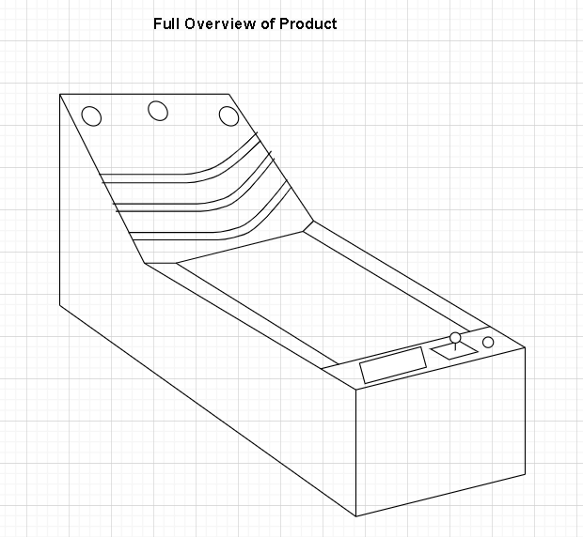

Fig 1. Preliminary Drawing

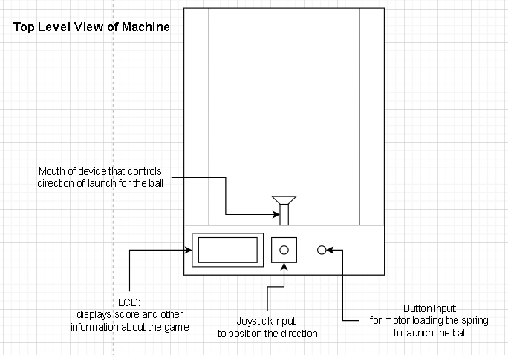

Fig 2. Top Level Perspective

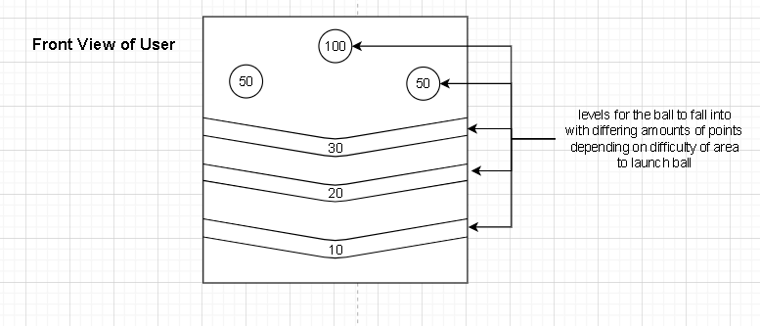

Fig 3. Front Facing Perspective